**📄**

**OOPS Assignment Submission**

**Student Details**

* Name: Rithik SR
* Registration No.: 2117240020314
* Department: CSE
* Section: F
* Subject Code: CS23312
* Subject Name: OOPS
* Assignment No.: Assignment 3

**1. Aim**

To implement Generic Array Utilities in Java that use generics to find the minimum, maximum, and average of elements in a generic array.

**2. Algorithm**

1. Start
2. Define a GenericArrayUtils class with generic methods:
   * findMin() – returns the smallest element
   * findMax() – returns the largest element
   * findAverage() – calculates the average (for numeric arrays only)
3. Use type bounds (extends Comparable) for min and max comparisons.
4. Use Number type bound for average calculation.
5. In the main() method:
   * Create arrays of Integer, Double, etc.
   * Call the utility methods and display the results.
6. End

**3. Java Code**

**class GenericArrayUtils {**

**// Method to find Minimum**

**public static <T extends Comparable<T>> T findMin(T[] arr) {**

**T min = arr[0];**

**for (T element : arr) {**

**if (element.compareTo(min) < 0)**

**min = element;**

**}**

**return min;**

**}**

**// Method to find Maximum**

**public static <T extends Comparable<T>> T findMax(T[] arr) {**

**T max = arr[0];**

**for (T element : arr) {**

**if (element.compareTo(max) > 0)**

**max = element;**

**}**

**return max;**

**}**

**// Method to find Average (for numeric arrays)**

**public static <T extends Number> double findAverage(T[] arr) {**

**double sum = 0.0;**

**for (T element : arr) {**

**sum += element.doubleValue();**

**}**

**return sum / arr.length;**

**}**

**}**

**// Main Class**

**public class GenericArrayTest {**

**public static void main(String[] args) {**

**Integer[] intArr = {10, 25, 5, 40, 15};**

**Double[] dblArr = {2.5, 7.3, 1.2, 9.8};**

**System.out.println("Integer Array:");**

**System.out.println("Min: " + GenericArrayUtils.findMin(intArr));**

**System.out.println("Max: " + GenericArrayUtils.findMax(intArr));**

**System.out.println("Average: " + GenericArrayUtils.findAverage(intArr));**

**System.out.println("\nDouble Array:");**

**System.out.println("Min: " + GenericArrayUtils.findMin(dblArr));**

**System.out.println("Max: " + GenericArrayUtils.findMax(dblArr));**

**System.out.println("Average: " + GenericArrayUtils.findAverage(dblArr));**

**}}**

**4. Output**

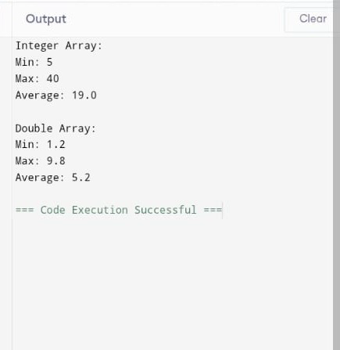

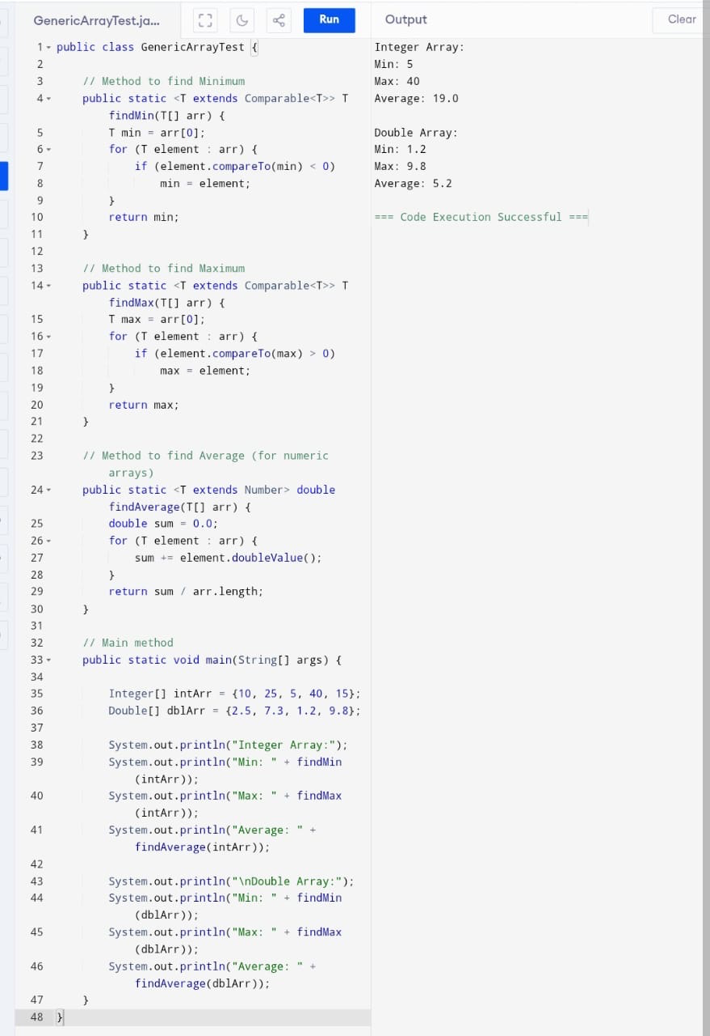**5. Screenshot**

**6. GitHub Repository Link**

https://github.com/rithikgomathy77-hue/Oops-Assignment.git